### Fall is in the Air and Its Pumpkins, Apples and Football Season

The leaves are starting to change color and I wanted to add some fall color to my house. I decided to create paper pumpkins, apples and a football with my Cameo Silhouette.

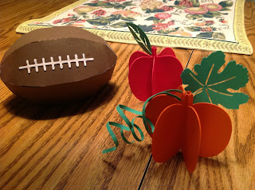There are twelve images to an 8 1/2 x 11 page. I used 6 images to create my pumpkin. You could use more if you would like. Fold them in half and apply glue to one side of each pumpkin as shown in the picture below and attach in a circle.

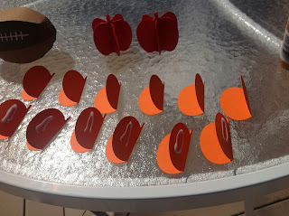

Again, there are twelve images to an 8 1/2 x 11 page. I used 6 images to create the apple. You can use more images if you would like. Assembly is the same as the pumpkins. Fold in half and apply glue to one side of each apple and attach in a circle.

The football is a little difficult to put together. I recommend gluing one side at a time and letting it dry before proceeding. Otherwise, you will get frustrated. I cut the laces on the same brown cardstock as the football. I painted the laces with white acrylic paint. If you don't have paint, you could cut it on white paper but I thought it would be more fun to paint it.

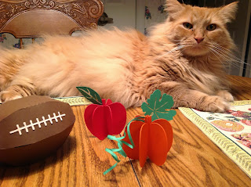

Marley loves to be part of my paper projects.